**MINI PROJECT**

**BASIC TO-DO-LIST APP USING PYTHON**

# Define an empty list to store tasks

tasks = []

# Function to display the to-do list

def display_tasks():

if not tasks:

print("No tasks in the to-do list.")

else:

print("To-Do List:")

for index, task in enumerate(tasks, start=1):

print(f"{index}. {task}")

# Function to add a task to the to-do list

def add_task(task):

tasks.append(task)

print(f"Task '{task}' added to the to-do list.")

# Function to delete a task from the to-do list

def delete_task(index):

if 1 <= index <= len(tasks):

delete_task = tasks.pop(index - 1)

print(f"Task '{delete_task}' removed from the to-do list.")

else:

print("Invalid index. Please provide a valid index.")

# function to mark task as completed

def complete_task(index):

if 1<= index <=len(index):

completed_task=todo_list.pop(index-1)

print(f"Task{completed_task}'marked as completed.")

else:

print("Invalid index.please enter valid task.")

# Main function to run the to-do list app

def main():

while True:

print("\n1. Display To-Do List")

print("2. Add Task")

print("3. Delete task")

print("4.complete task")

print("5. Quit")

choice = input("Enter your choice (1/2/3/4): ")

if choice == '1':

display_tasks()

elif choice == '2':

task = input("Enter the task: ")

add_task(task)

elif choice == '3':

index = int(input("Enter the index of the task to remove: "))

delete_task(index)

elif choice == '4':

print("Exiting the to-do list app. Goodbye!")

break

else:

print("Invalid choice. Please enter a valid option.")

if __name__ == "__main__":

main()

OUTPUT:

#Adding task

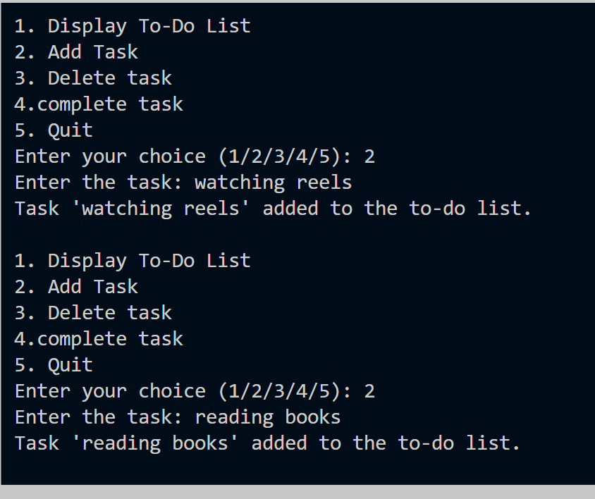

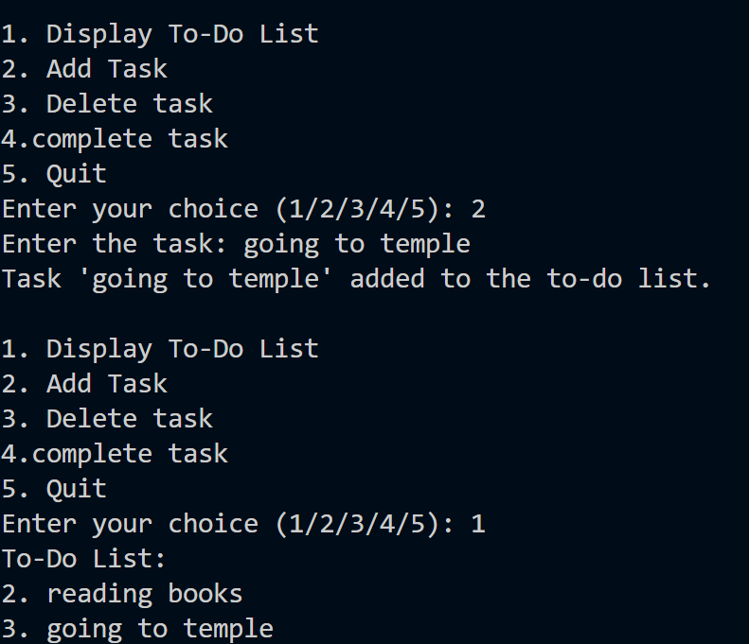

#Delete task and complete task

